May 22

May 27

May 29, 2025

June 2, 2025

June 3

June 4, 2025

June 5, 2025

June 11, 2025

June 12, 2025

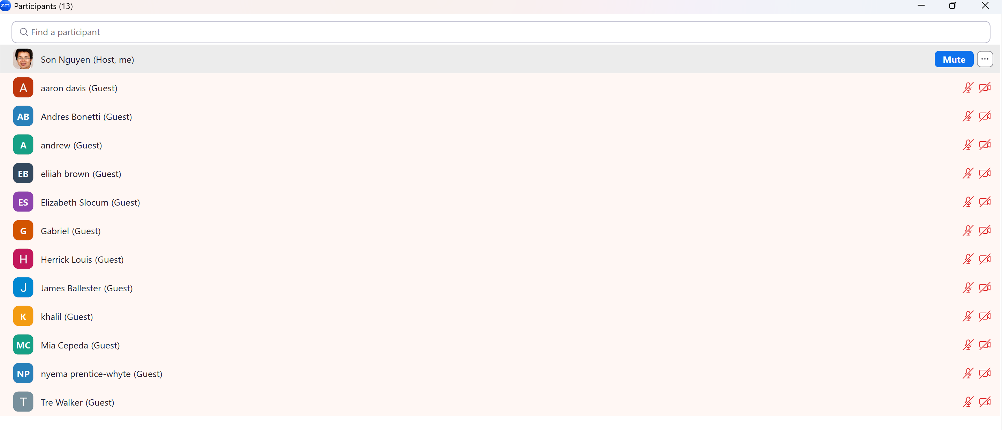

June 16

June 17, 2025

June 23

